

**Developers**

Lokesh Thummala(200388517)

Huashen Liang(200384499)

Kengo Muta(200389352)

Nestor Palacios Cifuentes(200375063)

**Table Of Contents**

Contents Page No.

1. About Website 1
2. Wireframes Section 2
3. ScreenShots 3
4. Future Functionality 4
5. **About Website**

This online survey form is not your ordinary online survey form. This surveys can be used to gather all types of the voice of customer feedback. This website’s survey templates can be customized with the questions and fields you want to be included. Our analytics tool will help you quickly tabulate results, and because our surveys live in the cloud, you’ll never have to worry about losing responses. Best of all, you don’t have to be a programmer to use a survey template–they’re easy and straightforward to send out. But if you are a programmer, you’ll love the behind-the-scenes functionality our online surveys provide.

This Survey’s site web app lets the user register an account on this website and can create a survey based on possible templates. The users can customize their own question and answers.

The users can create a life for the survey. An anonymous user can select a survey and can be able to respond to the survey.

A registered user will be able to get simple analysis for any survey that he or she owns including a number of respondents and survey answer statistics.

These services are provided in an efficient, cost-effective manner, with the goal of reducing the time and resources currently required for such tasks.

1. **Wireframes Section**

Home page:

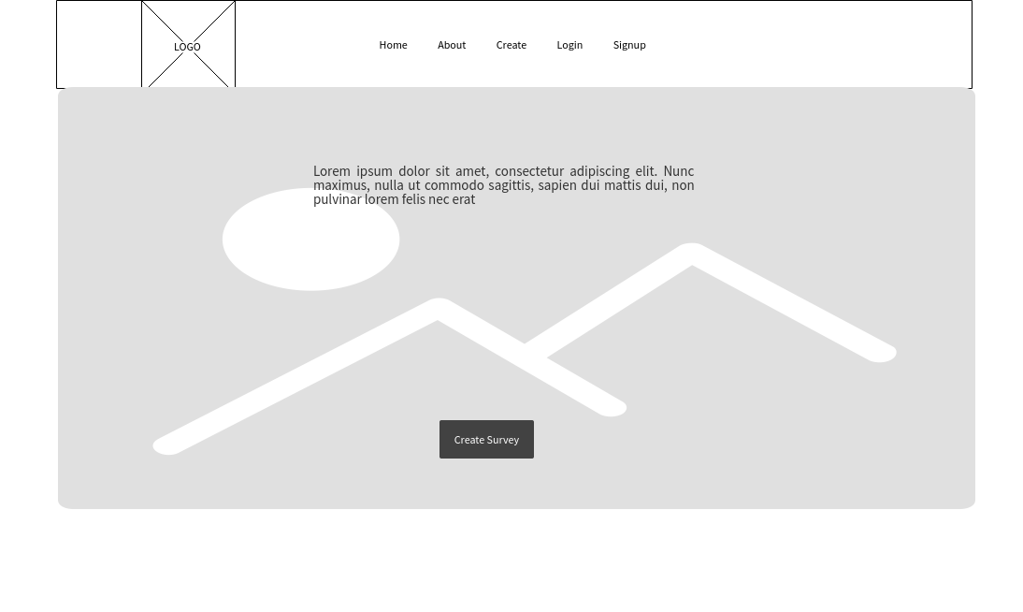

About Page:

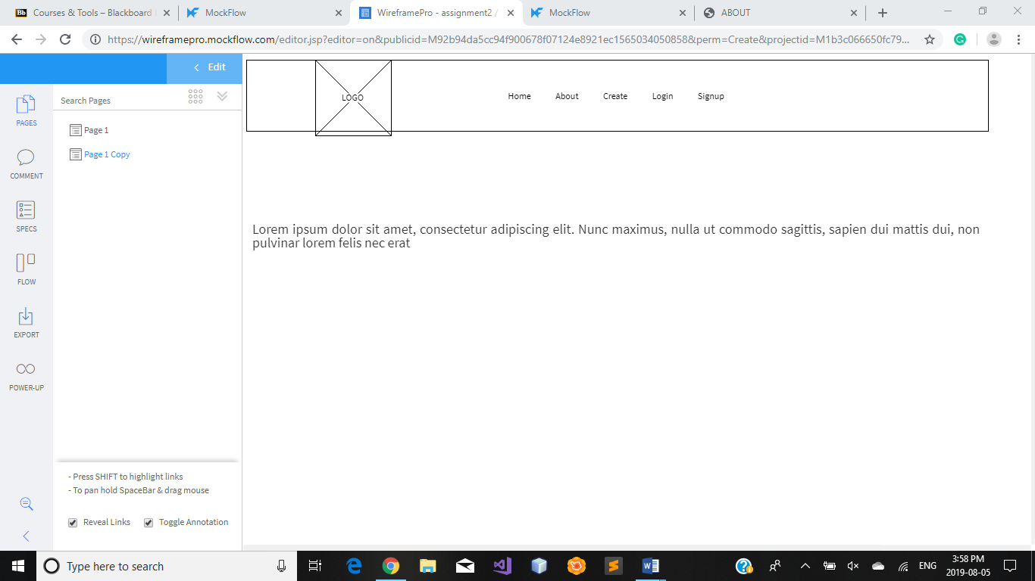

Create Page:

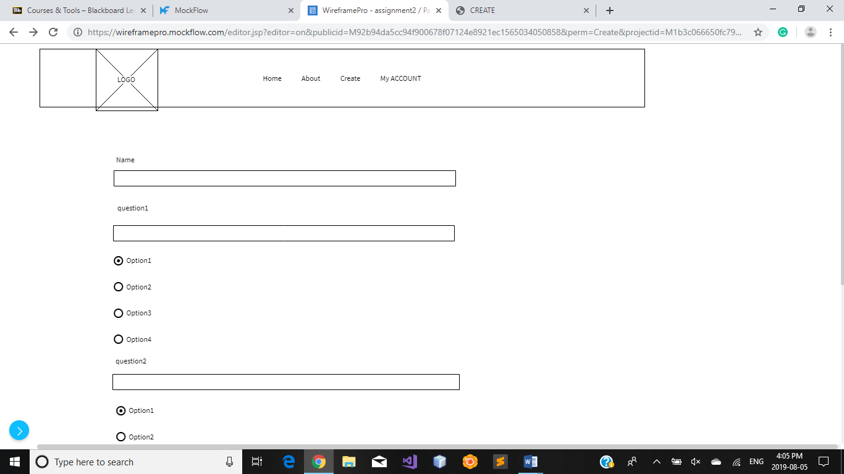

Login Page:

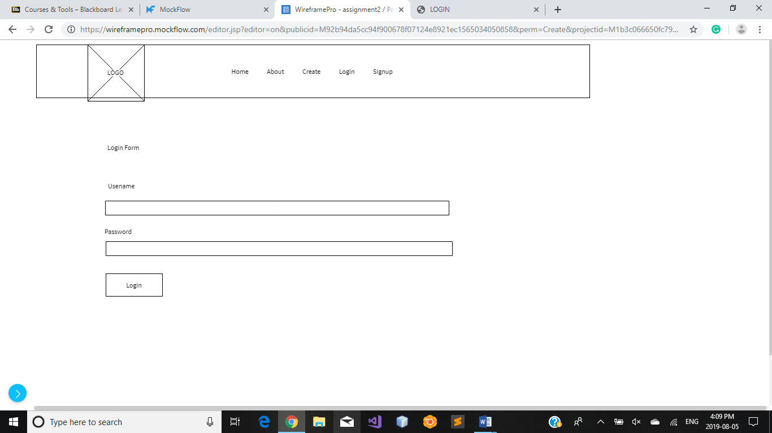

Signup Form Page:

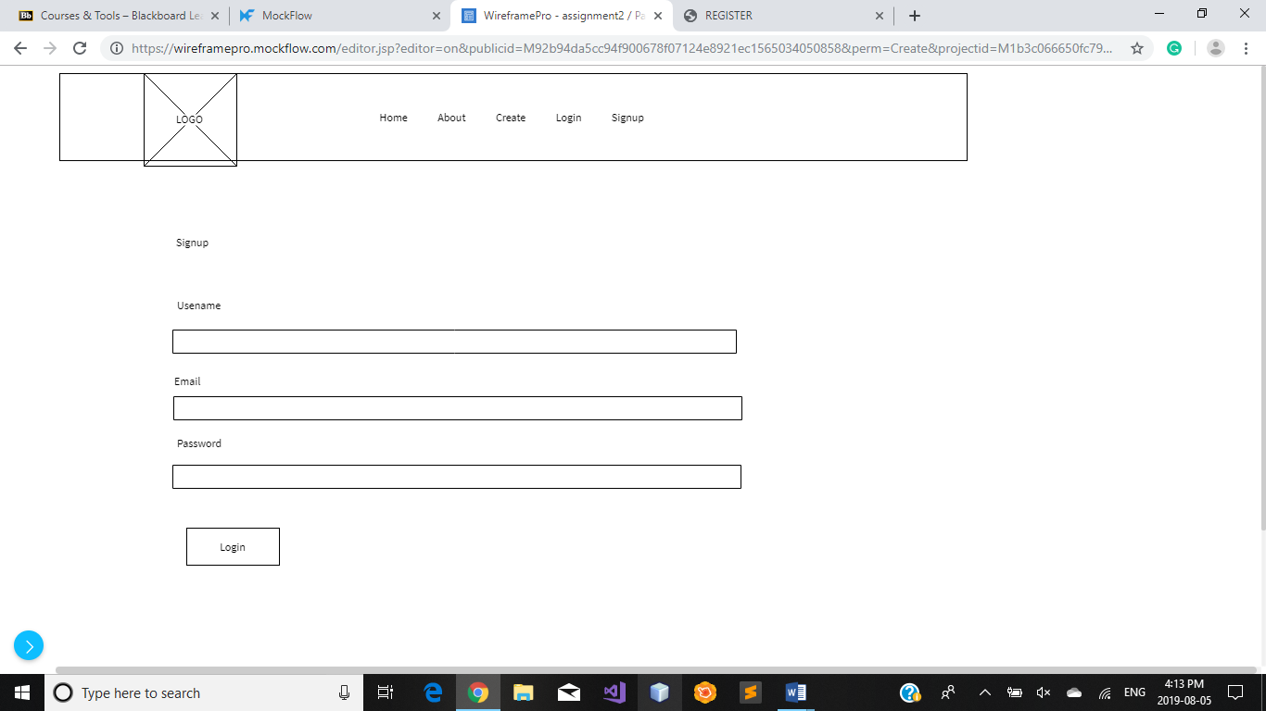

Update Account Page:

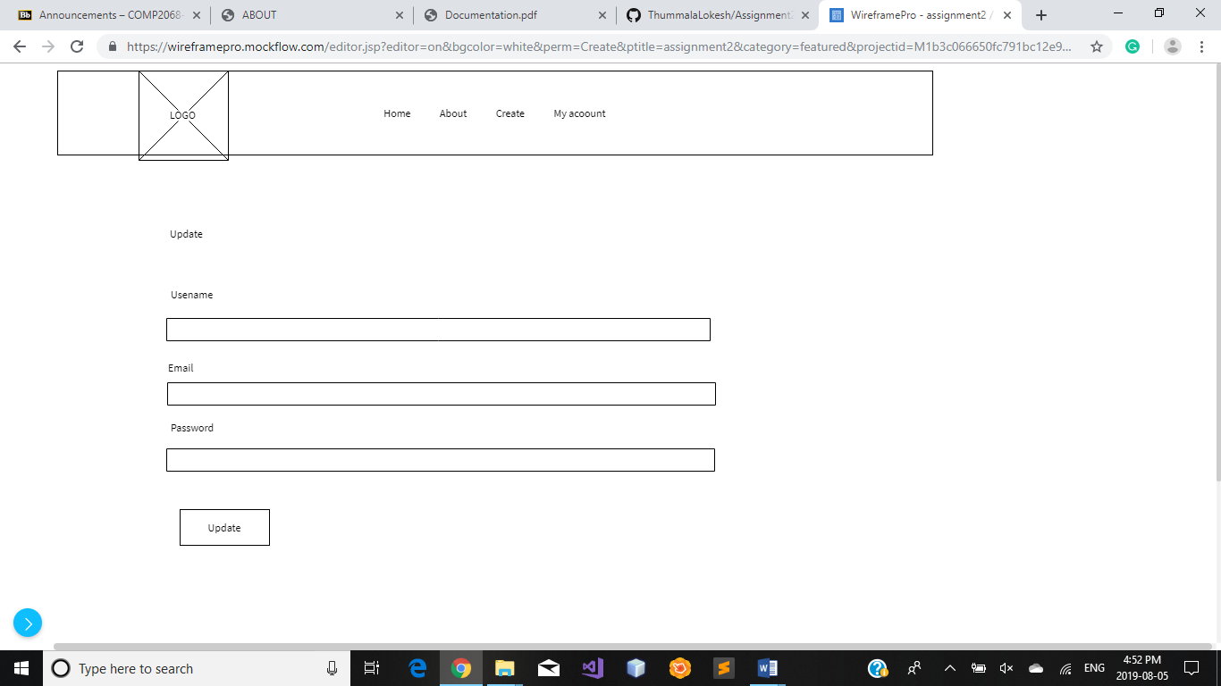

1. **ScreenShots**

Home Page:

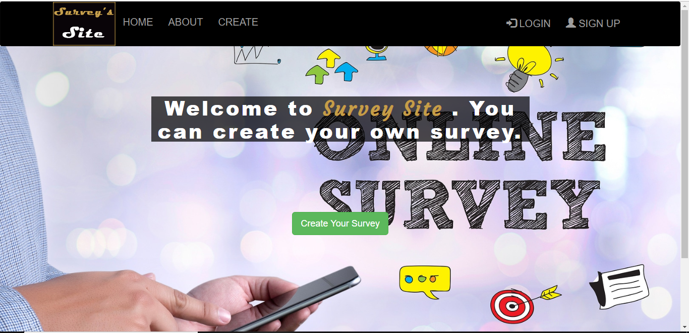

About Page:

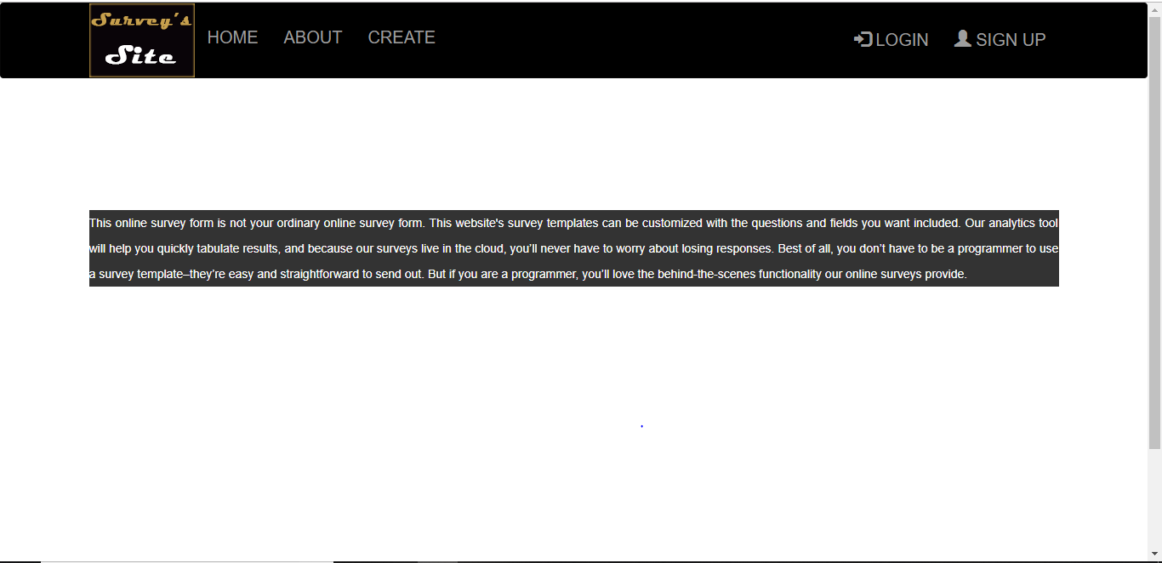

Signup Page:

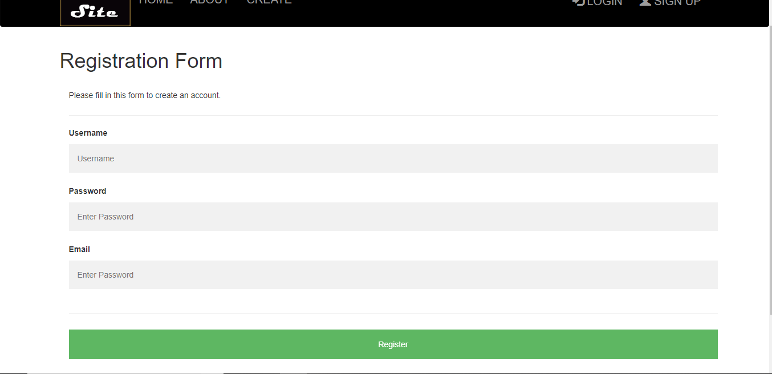

Creating Form Page:

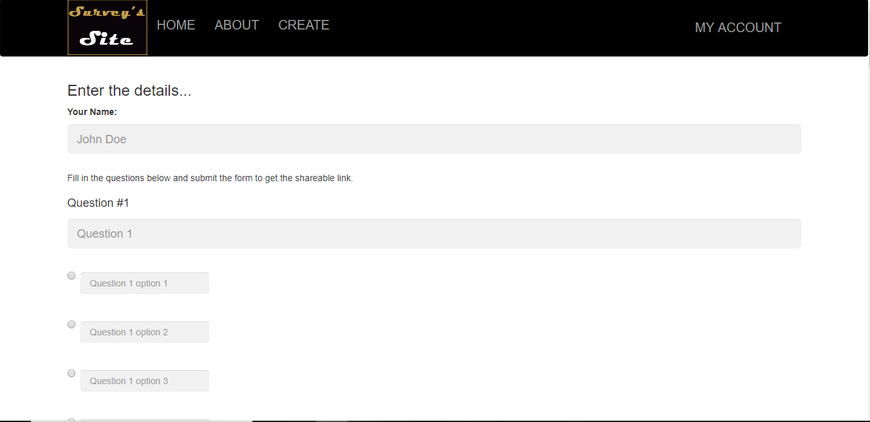

1. **Future Functionality**

This website has been developed in such a manner, that the future requirements of the user are met. The website is flexible to adapt to the changes efficiently without affecting the present system. In future, we include more facilities like more survey templates to choose.

We are also planning to implement this website as an application in various mobile platforms like Android and iOS.